
2010 JC2 H2 Prelim Exam Paper 1 Suggested Solutions

1 | 50 cm³ of a 0.10 mol dm⁻³ solution of a metallic salt was found to react exactly with 25.0 cm³ of 0.10 mol dm⁻³ aqueous sodium sulfite. In this reaction, the sulfite ion is oxidised as follows:  SO₃²⁻ (aq) + H₂O (l) → SO₄²⁻ (aq) + 2H⁺ (aq) + 2e  What is the new oxidation number of the metal in the salt if its original oxidation number was +3?
 | A | +1
 | B | +2
 | C | +4
 | D | +5

Solution: B
Amount of sulphite ions = = 0.0025 mol
Amount of metallic salt = 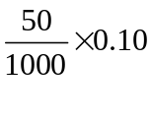 = 0.005 mol
Let x be the new oxidation no of metal in salt.

[R]: M³⁺ + (3-x)e → M^{x}

Since moles of electrons gained = moles of electrons lost in a redox reaction,

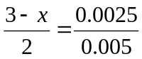
x = +2

2 | When methane, CH₄, was burned in an incorrectly adjusted burner, it was converted into a mixture of carbon dioxide and carbon monoxide in the ratio 99:1, together with water vapour.  What is the volume of oxygen consumed when y dm³ of methane is burned?
 | A | ( y – 0.01y) dm³
 | B | 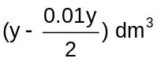
 | C | ( 2y – 0.01y ) dm³
 | D | 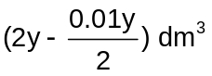

Solution: D

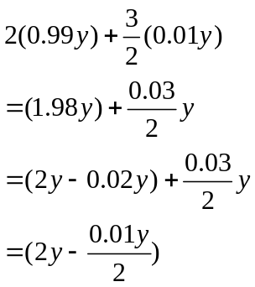
CH₄ + 2O₂ → CO₂ + 2H₂O
Volume of O₂ used =
y 2(0.99y) 0.99y

CH₄ + O₂ → CO + 2H₂O
y 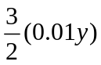 0.01y

3 | In an experiment, a sample of Americium element (Am) was vaporised, ionised and passed through an electric field. Analysis revealed that a beam of ²⁴¹Am⁺ gives an angle of deflection of 2 º.  What would be the angle of deflection for a sample of singly charged calcium ions?
 | A | 12.0 º
 | B | 6.0 º
 | C | 2.0 º
 | D | 0.3 º

Solution: A
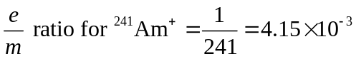
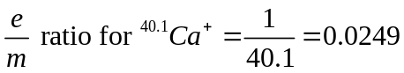
Since the e/m is 6 x ➔ 12 º

4 | Two elements A and B have the following properties:  - A and B form ionic compounds Na₂A and Na₂B respectively.  - Element B forms BF₆ molecule whereas A is not able to do so.  Which of the following pairs of electronic configuration for A and B is correct?
 |  | A B
 | A | [He] 2s² 2p⁴ [He] 2s² 2p²
 | B | [He] 2s² 2p² [He] 2s² 2p⁶ 3s² 3p³
 | C | [He] 2s² 2p² [He] 2s² 2p⁶ 3s² 3p²
 | D | [He] 2s² 2p⁴ [He] 2s² 2p⁶ 3s² 3p⁴

Solution: D

Both A and B will be in group VI as they form A²⁻ and B²⁻ with Na⁺.
Thus valence electronic configuration will be ns² np⁴.
B can form BF₆ molecule → implies that it can expand beyond octet structure → therefore it is an element in period 3 and above. Thus principal quantum number = 3.
5 | The ideal gas equation for n mol of gas is PV = nRT.  A graph of 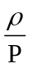verses P is obtained for a real gas C where 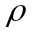= density of gas in g dm⁻³  and P = pressure of gas in atm.  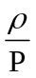  Y  P  At P = 0 atm and T = 273K, the relative molecular mass of C is
 | A | 273RY
 | B | 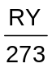
 | C | 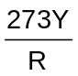
 | D | 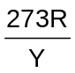

Solution: A

PV = nRT
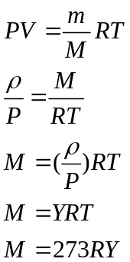

6 | A 2 g sample of hydrogen at temperature T and of volume V exerts a pressure P.  Deuterium, 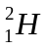 is an isotope of hydrogen.  Which of the following would also exert a pressure of P at the same temperature T?
 | A | A mixture of 2 g of hydrogen and 2 g of deuterium of total volume 2V
 | B | A mixture of 1 g of hydrogen and 2 g of deuterium of total volume 2V
 | C | A mixture of 1 g of hydrogen and 2 g of deuterium of total volume V
 | D | A mixture of 1 g of hydrogen and 1 g of deuterium of total volume V

Solution: C
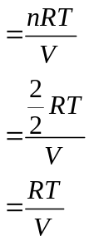P (of sample of 2 g of hydrogen) V = nRT
P (of sample of 2 g of hydrogen)

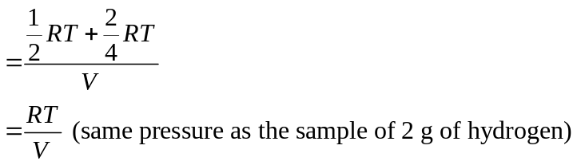For option C:
P (of mixture)

7 | Which one of the following statements best explains why the boiling point of butanone (79.6 ºC) is higher than that of pentane (36.1 ºC)?
 | A | The relative molecular mass of butanone is higher than that of pentane.
 | B | The butanone molecule has a larger surface area than the pentane molecule.
 | C | The covalent bonds in butanone molecules are stronger than those in the pentane molecules.
 | D | There are stronger dipole interactions between butanone molecules but only weak interactions between pentane molecules.
Solution: D
Permanent dipole-dipole interaction exist between the butanone due to the presence of polar C=O bond. Pentane only has weak induced dipole-dipole interactions.

8 | Which of the following statements about the structures of graphite and diamond is correct?
 | A | Graphite has a shorter carbon-carbon bond length due to the overlap of sp² orbitals.
 | B | Diamond has a shorter carbon-carbon bond length due to the overlap of sp² orbitals.
 | C | All covalent bonds in diamond are of the same length but those in graphite are not.
 | D | The C-C-C bond angle is larger in diamond than in graphite.

Solution: A
9 | The distribution of the fraction of molecules with energy for two temperatures, T₁ and T₂ are shown in the diagram below.  D, F and G refer to the different shaded areas under the two graphs.  T₂  T₁  Fraction of molecules with energy, E  T₁ < T₂  E_{a} = Activation Energy  Energy  E_{a}  D  G  F
 | Which expression gives the fraction of molecules having at least the activation energy at higher temperature, T₂?
 | A | 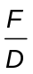
 | B | 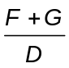
 | C | 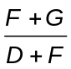
 | D | 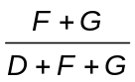

Solution: C
Total number of molecules (area under graph T₁) = D + F
No of molecules with energy greater than E_{a} for T2 = F + G
Hence the fraction of molecules = 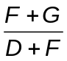

10 | Consider the following equilibrium system:  Fe₃O₄(s) + CO(g) CO₂(g) + 3 FeO(s)  It is a slightly endothermic reaction at room temperature.  Which of the following changes is correct?
 | A | Decreasing the temperature causes the position of equilibrium to shift to the left.
 | B | Increasing pressure of CO(g) causes the position of equilibrium to shift to the left.
 | C | Adding Fe₃O₄(s) causes the position of equilibrium to shift to the right.
 | D | Reducing [CO₂(g)] causes the position of equilibrium to shift to the left.

Solution: A
When temperature decreases, by Le Chatelier’s Principle, system will try to increase temperature by favouring the backward exothermic reaction.

11 | What is the pH of a solution formed by mixing 0.45 g of lactic acid and 0.84 g of sodium lactate in a 500 cm³ beaker?  (Given K_{a} of lactic acid = 1.34 x 10⁻⁴ mol dm⁻³, M_{r} of lactic acid = 90, M_{r} of sodium lactate = 112)
 | A | 3.60
 | B | 3.70
 | C | 3.87
 | D | 4.05

Solution: D
[Salt] = 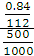 = 0.01500 mol dm⁻³

[Acid] = 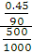 = 0.01000 mol dm⁻³

pH = -lg(1.34 x 10⁻⁴) + lg () = 4.05

12 | Which graphs below correctly represents how ΔG varies with temperature for the combustion of octane?
 | A  ΔG / kJ mol^{–1} | T / K
 | B  ΔG / kJ mol^{–1} | T / K
 | C  ΔG / kJ mol^{–1} | T / K
 | D  ΔG / kJ mol^{–1} | T / K
Solution: D
ΔG = ΔH - TΔS
At T=0, ΔG = ΔH = -ve since combustion is an exothermic process.
ΔS for combustion of octane is positive (increase in disorderness as gaseous products are formed)
Thus, as temperature increases, ΔG will become more negative as the term “-TΔS” becomes more negative.
13 | When the switch in the circuit shown below is closed, a steady current of 5 A is passed through the electrolyte for 32 min at s.t.p.  Which statement is incorrect?  Bronze anode (an alloy of copper and tin)  switch  100 cm³ of 0.1 mol dm^{–3} dilute sulphuric acid  platinum cathode
 | A | The anode becomes silvery in colour.
 | B | About 1.11 dm³ of gas will be collected at the cathode.
 | C | A straight line graph showing mass of the anode decreasing with time can be obtained.
 | D | Litmus solution turns blue when added around the cathode.

Solution: A

- Based on E° values in Data Booklet, tin will undergo oxidation first (E° is less positive), leaving copper behind. Thus, the colour of the solid should be pink.

- Water is reduced & hydrogen gas is collected at the cathode.
Q = It = 32 x 60 x 5 = 9600 C
Amt of H₂ collected = Q/n_{e}F = 9600/2(96500) = 0.0497 mol
Vol of H₂ collected = 0.0497 x 22.4 = 1.11 dm³

- Since the amount of charge passing through is constant, thus the amount of tin that is oxidised will be constant as well. Therefore, the graph should be a straight line.

- Hydroxide ions is produced at the cathode together with H₂ gas, which will cause litmus to turn blue.

14 | Element S forms a chloride which dissolves in water to give an acidic solution. It also forms an oxide which dissolves readily in acids.  What could S be?
 | A | Calcium
 | B | Aluminium
 | C | Silicon
 | D | Phosphorus

Solution: B

Al³⁺ has high charge density and is able to polarize water molecules to release H⁺. Hence AlCl₃ dissolves in water to give an acidic solution. Al₂O₃ is an amphoteric oxide which is able to neutralize and dissolves in acids.

15 | The use of Data Booklet is relevant for this question.  The graph below shows the second ionisation energies of four elements, numbered 1 to 4.  The elements are adjacent to each other in the Periodic Table.  Second ionisation energy (arbitrary units)  Atomic number  1  2  3  4  Which statement about the elements 1 to 4 is incorrect?
 | A | The melting point of the elements increases in the order of 1 < 2 < 3 < 4
 | B | The atomic radius of the elements decreases in the order of 2 > 3 > 4 > 1
 | C | The third ionisation energy of the elements decreases in the order of 3 > 2 > 1 > 4
 | D | The covalent character of the chlorides of the elements increases in the order 1 > 2 > 3 > 4

Solution: D
The use of Data booklet IE information is encouraged.
The atomic number increases from Group VIII, I, II and III.P

16 | Which of the following is NOT true about Group II compounds?
 | A | Solubility of Group II sulfates increases down the group.
 | B | Calcium nitrate decomposes on heating to give the corresponding oxide, NO₂ gas and O₂ gas.
 | C | Reactivity of Group II oxides with water increases down the group.
 | D | Lattice energy of Group II oxides becomes less exothermic down the group.

Solution: A

Statement A is wrong as solubility of Gp II sulphates decreases down the group.

17 | Group II carbonates decompose according to the following equation:  MCO₃ (s) → MO (s) + CO₂ (g)  Which of the following factor helps to explain this trend?
  Element | Mg | Ca | Sr | Ba
  ∆H/ kJ mol⁻¹ | +101 | +178 | +235 | +269
 | A | The electronegativity of the elements decreases down the group.
 | B | The reducing power of the elements increases down the group.
 | C | The ionic radius increases down the group.
 | D | The relative formula mass of the carbonate increases down the group.

Solution: C
As ionic radius increases down the group, charge density & polarizing power of cation decreases. Polarising effect on CO₃²⁻ decreases. Thermal stability of Group II carbonates increases and more energy is required for decomposition.

18 | Which of the following statements is true about hydrogen halides?
 | A | Enthalpy change of formation becomes less exothermic down the group.
 | B | Thermal stability increases down the group.
 | C | Acidity of the corresponding aqueous solution decreases down the group.
 | D | Charge density of cation decreases down the group.

Solution: A

19 | Astatine is below iodine in Group VII.  Which of the following would be a correct prediction for astatine and its compounds?
 | A | Astatine would oxidise chloride to chlorine.
 | B | Potassium astatide would be a white crystalline solid.
 | C | Astatine is insoluble in chloroform.
 | D | Silver astatide reacts with concentrated aqueous ammonia to form a soluble complex.

Solution: B
Statement A: Incorrect, At is weak oxidising agent
Oxidising power of halogen decreases down the group.
Statement B: Correct
KAt is an ionic compound. Hence it has a high melting point and will exists as a solid.
Statement C: Incorrect
Astatine is soluble in chloroform which is an organic solvent. (favourable solute-solvent interaction).
Statement D: Incorrect
Silver astatide do not react with concentrated aqueous ammonia to form a soluble complex as the K_{sp} of silver astatide is too low.

20 | Chromium(III) chloride combines with ammonia to form compound T in which the coordination number of chromium is 6. When solution T is treated with an excess aqueous silver nitrate, only one third of the total chloride present is precipitated as AgCl.  What is the formula of compound T?
 | A | Cr(NH₃)₃Cl₃
 | B | Cr(NH₃)₄Cl₃
 | C | Cr(NH₃)₅Cl₃
 | D | Cr(NH₃)₆Cl₃

Solution: B

Free Cl⁻ (not bonded to Cr³⁺) = Cl⁻ precipitated as AgCl
No of Cl⁻ bonded to Cr³⁺ = 3-1 = 2
Since coordination number of Cr = 6, there must be 2 Cl⁻ and 4 NH₃ ligands bonded to Cr³⁺.
Formula of T: [Cr(NH₃)₄Cl₂]⁺ Cl⁻ which is the same as Cr(NH₃)₄Cl₃.

21 | The structure of Ergocalciferol, also known as vitamin D₂ is shown below:  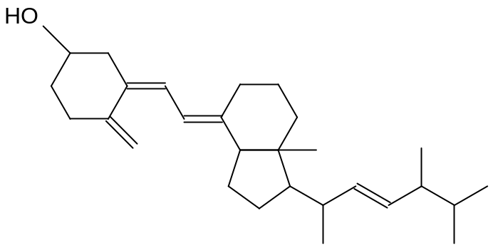  Ergocalciferol  How many optical isomers are present in this molecule?
 | A | 6
 | B | 8
 | C | 12
 | D | 64

Solution: D
*
*
*
*
*
*
Total no of optical isomers = 2⁶ ⁼ 64

22 | Which of the following is NOT the product formed when butene reacts with IBr (aq)?
 | A | 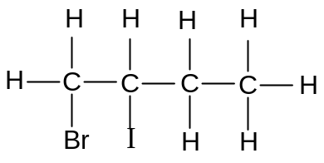
 | B | 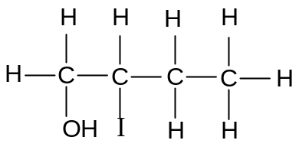
 | C | 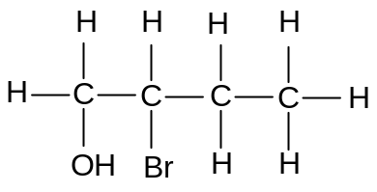
 | D | 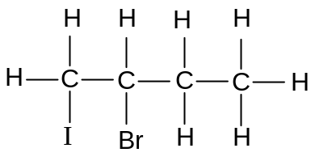

Solution: C

In IBr(aq), electrophile is I⁺ and nucleophiles are Br⁻ and OH⁻.
Intermediate formed is either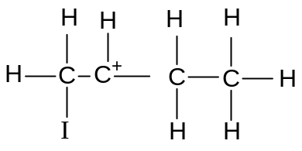or 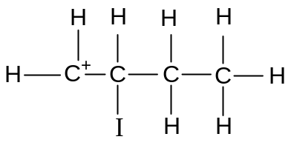

23 | Pyrogallol is a powerful reducing agent that is used to remove oxygen. When 15 cm³ of a gaseous hydrocarbon is combusted with 180 cm³ of oxygen, there was a contraction of 52.5 cm³. On further treatment with pyrogallol, there was a reduction of 82.5 cm³.  What is the molecular formula of the hydrocarbon?  (All volumes are measured at room temperature and pressure.)
 | A | C₃H₈
 | B | C₄H₈
 | C | C₄H₁₀
 | D | C₅H₁₀

Solution: C

Volume of gases left after combustion = (15 + 180) – 52. 5 = 142.5 cm³
Volume of unreacted oxygen = 82.5 cm³
Volume of CO₂ = 142.5 – 82.5 = 60 cm³
Volume of oxygen reacted = 180 – 82.5 = 97.5 cm³
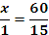
x = 4
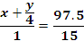
y = 10
Therefore, the hydrocarbon is C₄H₁₀.

24 | When hot NaOH is added to compounds H and J, C₆H₅CH₂OH and C₆H₅CH=CH₂ are formed respectively. What could compounds H and J be?
 |  | H | J
 | A | 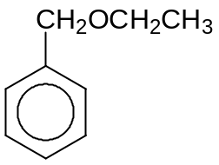 | 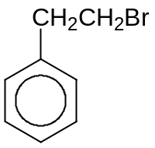
 | B | 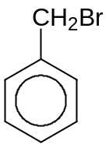
 | C |  | 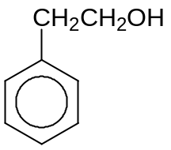
 | D

Solution: B

Nucleophilic substitution and elimination will occur for H and J respectively

25 | Which one of the following will be formed when butane-1,3-diol is distilled with hot alkaline potassium manganate (VII)?
 | A | CH₃COCH₂CHO
 | B | CH₃COCH₂COOH
 | C | CH₃CH(OH)CH₂COO–
 | D | CH₃COCH₂COO–

Solution: D

2º alcohol is oxidised to a ketone while 1º alcohol is oxidised to a carboxylic acid even though the reaction is distilled in the presence of a strong oxidizing agent, MnO₄⁻. Carboxylic acid formed will be neutralized by the basic medium present.

26 | The following reagents were added to K and M and the observations were made:  What could be the structural formulae of K and M?
  Reagents | Observation
  Alkaline aqueous iodine | Brown iodine decolourises for K but not M
  Acidified potassium dichromate (VI) | Green solution seen for K but not M
  Aqueous bromine | M decolourise reddish brown bromine but not K
 |  | K | M
 | A | 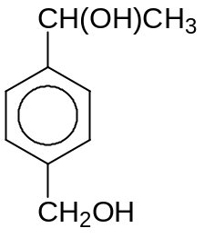 | 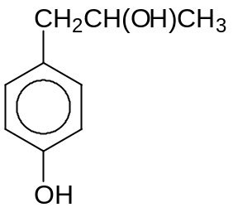
 | B | 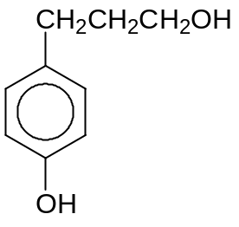 | 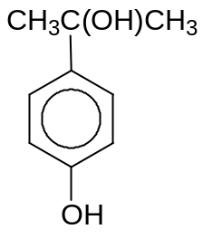
 | C
 | D

Solution: C

K undergoes oxidation while M (contains phenol) undergoes easy electrophilic substitution with aq iodine.
K is not phenol because it does not decolourise aq bromine.
M is 3º alcohol because it can’t be oxidized further with acidified K₂Cr₂O₇.

27 | Compounds N and P are first reacted with hot aqueous NaOH followed by dilute HCl at room temperature.  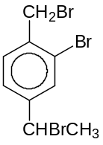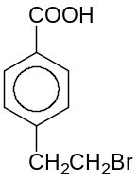  Compound N Compound P  Which reagents could be used to distinguish the final products of N and P?
 | A | H₂, Ni catalyst
 | B | Iodine in aqueous NaOH
 | C | Phosphorus pentachloride
 | D | Na metal

Solution: B

The halogenoalkanes will undergo nucleophilic substitution to give alcohols.

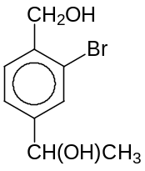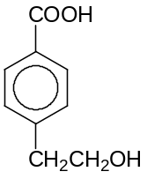

28 | Compound Q can be converted to compound R in a sequence of steps.  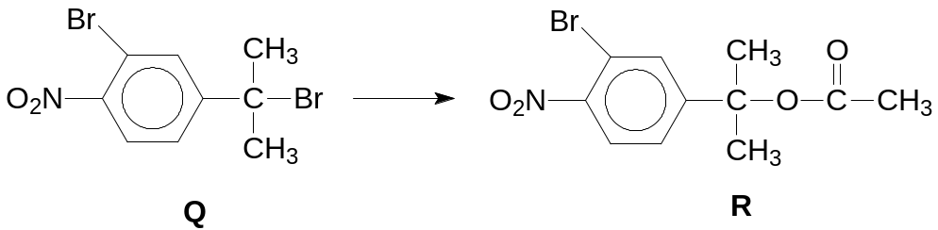  Which of the following statements is correct?
 | A | The sequential conversion of Q to R involves a nucleophilic substitution reaction, acidic hydrolysis and esterification.
 | B | Compound Q must be converted into an alkene first in the first step of conversion to compound R.
 | C | Neutralisation occurs when aqueous sulfuric acid is added to Q and R separately at rtp.
 | D | When hot aqueous sodium hydroxide is added separately to compounds Q and R, only compound Q gives a cream precipitate when added to silver nitrate solution.

Solution: D

A The sequential conversion of Q to R involves a nucleophilic substitution and esterification reaction.

B Compound Q must be converted into an alcohol first in the first step of conversion to compound R.

C There are no basic groups present in Q and R to undergo neutralization with aq H₂SO₄.

D 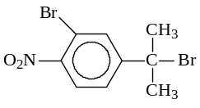 + NaOH →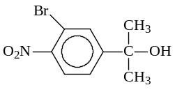+ NaBr

Br⁻ + Ag⁺ → AgBr (cream ppt)

29 | Which procedure gives the best yield of phenylbenzoate, C₆H₅CO₂C₆H₅?
 | A | Reacting C₆H₅CO₂H with SOCl₂, then adding C₆H₅OH.
 | B | Reacting C₆H₅OH with NaOH, then adding C₆H₅COCl.
 | C | Refluxing a mixture C₆H₅CO₂H and C₆H₅OH with concentrated H₂SO₄.
 | D | Reacting C₆H₅OH with SOCl₂, then adding C₆H₅CO₂H.

Solution: B

Phenoxide ion is a stronger nucleophile compared to phenol where nucleophilic substitution takes place more readily.

30 | Consider the following four compounds:  What is the relative order of decreasing basicity of these compounds?
  1 | phenylamine
  2 | 2-bromopropylamine
  3 | 3-chloropropanamide
  4 | propylamine
 | A | 3 | 2 | 4 | 1
 | B | 2 | 4 | 1 | 3
 | C | 4 | 2 | 1 | 3
 | D | 2 | 3 | 4 | 1

Solution: C

- Propylamine is the most basic as the present of the electron-donating alkyl group increases the availability of the lone pair on N atom to accept protons via dative bonds.
- Electron-withdrawing Br on 2-bromopropylamine decreases the availability of the lone pair on N atom to accept protons via dative bonds and thus 2-bromopropylamine will be less basic than propylamine.
- Phenylamine is less basic than 2-bromopropylamine as the lone pair electron on N atom is delocalised into the pi electron cloud of the benzene ring.
- 3-chloropropanamide is neutral in nature, and thus it is the least basic among the 4 compounds.

Decreasing basicity: Most → Least Basic

For questions 31 – 40, one or more of the numbered statements 1 to 3 may be correct. Decide whether each of the statements is or is not correct. The responses A to D should be selected on the basis of
A | B | C | D
1, 2 and 3  are correct | 1 and 2 only  are correct | 2 and 3 only  are correct | 1 only  is correct

No other combination of statements is to be used.
31 | Which of the following contain(s) hydrogen bonds?
 | 1 | NH₄Cl (s)
 | 2 | NH₃ (l)
 | 3 | HNO₃ (l)

Solution: C (2 & 3 are correct)
Option 1: The N in NH₄⁺ does not contain lone pair of electrons for H-bonding.
Option 2: 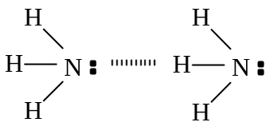
Option 3: 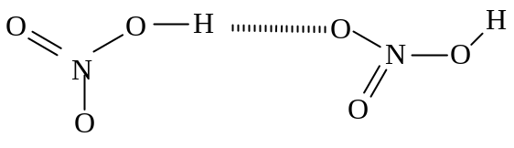

32 | Bromine and methanoic acid react as follows:  Br₂ (aq) + HCO₂H (aq) → 2Br⁻ (aq) + 2H⁺ (aq) + CO₂ (g)  The order of reaction with respect to bromine and methanoic acid are found to be one respectively.  Which of the following statement(s) is / are correct?
 | 1 | Doubling the concentration of methanoic acid doubles the rate of evolution of gas.
 | 2 | Halving the concentration of both reactants simultaneously will halve the reaction.
 | 3 | The overall order of reaction is one.

Solution:D (1 only is correct)
Option 1: When [methanoic acid] is doubled, rate is doubled.
Option 2: When both [Br₂] and [methanoic acid] are halved, rate decrease by 4 times.
Option 3: The overall order of reaction is 2.

33 | For the reaction: N₂O₄(g) 2NO₂(g)  the numerical values of K_{p} at two different temperatures are given as follows:  Which of the following statement(s) is / are correct?
  Temperature/ K | K_{p}
  500 | 1.70 x 10³
  600 | 1.78 x 10⁴
 | 1 | The proportion of NO₂ in the equilibrium mixture is increased by decreasing the pressure.
 | 2 | The standard enthalpy change of the forward reaction is negative.
 | 3 | The units for K_{p} are atm⁻¹.

Solution: D (1 only is correct)
Option 1: Position of equilibrium shifts to right to increase number of gaseous molecules when pressure is reduced.
Option 2: standard enthalpy change of the forward reaction should be positive since value of K_{p} increases when temperature is increased.
Option 3: Units for K_{p} should be atm.

34 | In an acid-base titration, 25.0 cm³ of 0.150 mol dm⁻³ HCl was titrated with 0.150 mol dm⁻³ NH₃. The table below shows the data of four acid-base indicators.  Which of the following show(s) the correct indicator used with their corresponding colour observed in the above titration?
  Indicator | Approximate pH range | Colour change
  Indicator | Approximate pH range | In acid | In alkali
  Congo red | 3.0 – 5.0 | Blue-violet | Red
  Bromocresol green | 3.8 – 5.5 | Yellow | Blue
  Cresol red | 7.2 – 8.8 | Yellow | Reddish – purple
 |  | Indicator Colour at end-point
 | 1 | Congo red violet
 | 2 | Bromocresol green green
 | 3 | Cresol red orange

Solution: B (1 & 2 are correct)

Region of rapid pH change for a strong acid - weak base titration is between pH 3 to pH 7

.
35 | Which of the following statement(s) regarding alkyl halides is/are true?
 | 1 | Chlorofluorocarbons are suitable to be used as aerosol because it does not react with the compounds that it is carrying and it is very volatile.
 | 2 | Chlorofluorocarbons are non-biodegradable because they are chemically inert.
 | 3 | Chlorofluorocarbons slowly diffuse towards the upper atmosphere where they are cleaved into fluorine radicals by UV light.

Solution: B (1 & 2 are correct)
Chlorine radical is formed, not fluorine radicals as C-F bonds are very strong.

36 | Which of the following statement(s) is / are true when the compound below reacts with hot aqueous H⁺?  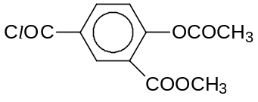
 | 1 | White fumes are observed.
 | 2 | A white precipitate is observed.
 | 3 | Hydrolysis has taken place.

Solution: A (1,2 & 3 are correct)

All the options are correct.

- White fumes of HCl are observed when acyl chloride undergoes hydrolysis.
- A white precipitate of benzoic acid is observed when acidic hydrolysis of ester takes place.
- Hydrolysis has taken place.

37 | Haemoglobin is the iron-containing oxygen-transport metalloprotein found in the red blood cells of vertebrates and the tissues of some invertebrates.  The following fragments were obtained after hydrolysis of a typical haemoglobin molecule:  leu  his-leu-thr  pro-glu  thr-pro  Which statement(s) is / are correct?
 | 1 | The form H₃N⁺CHRCO₂– is the most common species for any amino acids at pH=7
 | 2 | The fragments may be obtained when haemoglobin is heated in 6 mol dm⁻³ NaOH(aq).
 | 3 | The sequence of the haemoglobin chain should be -his-leu-thr-pro-glu-.

Solution: C (2 & 3 are correct)
- Different amino acids will exist as zwitterions at their respective isoelectric point which need not be pH=7.
- Basic hydrolysis occurred where peptide bonds are broken.
- By observing overlapping patterns, the original sequence of haemoglobin could be deduced:

his-leu-thr
leu
thr-pro
pro-glu

38 | Use of the Data Booklet is relevant to this question.  The exhaust systems of most new cars are fitted with catalytic converters that contain transition metals as catalysts to decrease the emission of atmospheric pollutants. Platinum and palladium are the two most common elements used.  Which of the following statement(s) is/are correct?
 | 1 | Palladium and platinum can exist in variable oxidation states.
 | 2 | Palladium and platinum have similar atomic radii.
 | 3 | On addition of lead to the catalytic convertor the rate of removal of oxides of nitrogen will be accelerated.

Solution: D (1 is correct)

Catalyst poisoning occurs when the catalytic converter is exposed to exhaust containing substances that coat the working surfaces, encapsulating the catalyst so that it cannot contact and treat the exhaust. The most notable contaminant is lead, so vehicles equipped with catalytic converters can only be run on unleaded gasoline
Palladium and platinum do not have similar atomic radii
39 | When iron filings are added to nitric acid, a brown gas is formed. On the addition of ammonium thiocyanate, a blood red colouration due to an iron (III) complex is formed.  Which statement (s) is / are correct?
 | 1 | Iron acts as a reducing agent.
 | 2 | The standard cell potential of the reaction between iron filings and nitric acid is +0.85V.
 | 3 | Addition of potassium cyanide into the reaction between iron filings and nitric acid will result in an increase in the standard cell potential.

Solution: A (1, 2, & 3 are correct)
Question has indicated that a brown gas is formed. This gas should be NO₂.
From the knowledge of transition chemistry, students should know that the blood red colouration after the addition of the thiocyante is a Fe³⁺ complex. This means that Fe → Fe³⁺. Iron undergoes oxidation, and hence is a reducing agent

From the Data Booklet, E_{cell} = E_{(NO3-/NO2)} – E_{(Fe3+/Fe)} = 0.81 – (–0.04) = +0.85 V
Addition of KCN will result in the formation of a cyanoferrate (III) complex. This reduces the [Fe³⁺], thus shifting the position of the equilibrium for the Fe³⁺/Fe half cell to the left. Favouring the oxidation of Fe. This makes E_{(oxd)} more negative, and thus E_{cell} is more positive.

40 | An element X has the electronic configuration [Ar]3d³4s² and forms a series of oxo-compound.  Which of the following species of X are likely to be formed?
 | 1 | XO₂⁺ and XO₃
 | 2 | XO₃⁻ and XCl₃
 | 3 | XO²⁺ and XO₃²⁻

Solution: C (2 & 3 only)
Statement one is wrong as X cannot exist in +6 oxidation state.
+5, +4 and +3 oxidation states of X are possible.

-END OF PAPER-

